**Project 1-Deployment the website on AWS EC2 Instance**

**Virtual private cloud**

Steps:

1. In AWS console, search VPC.

2. In VPC dashboard, you will get my VPC's and click on myvpc's.

3. Click on create VPC. Select resource to create as vpc only.

4. Give name as deek-vpc and IPv4 CIDR as 10.0.0.0/16.

5. Then click on create VPC.

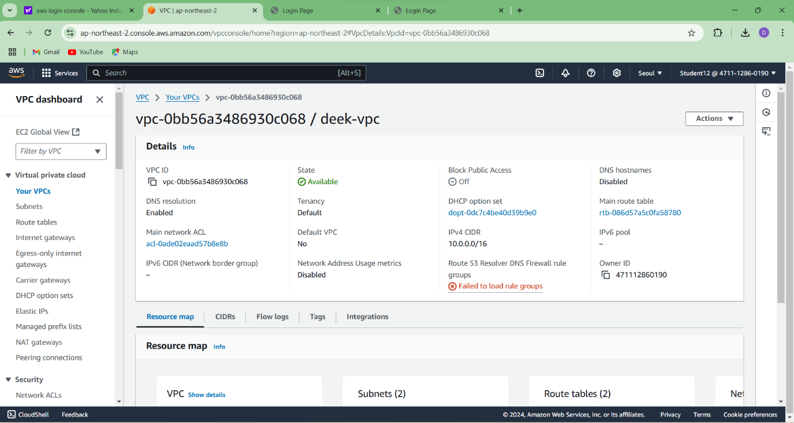

**Internet gateway**

Steps:

1. In VPC dashboard, click on Internet Gateway.

2. To create Internet gateway, click on create Internet Gateway

3. Then give name as deek-igw and click on create Internet Gateway.

4. Your internet Gateway is created.

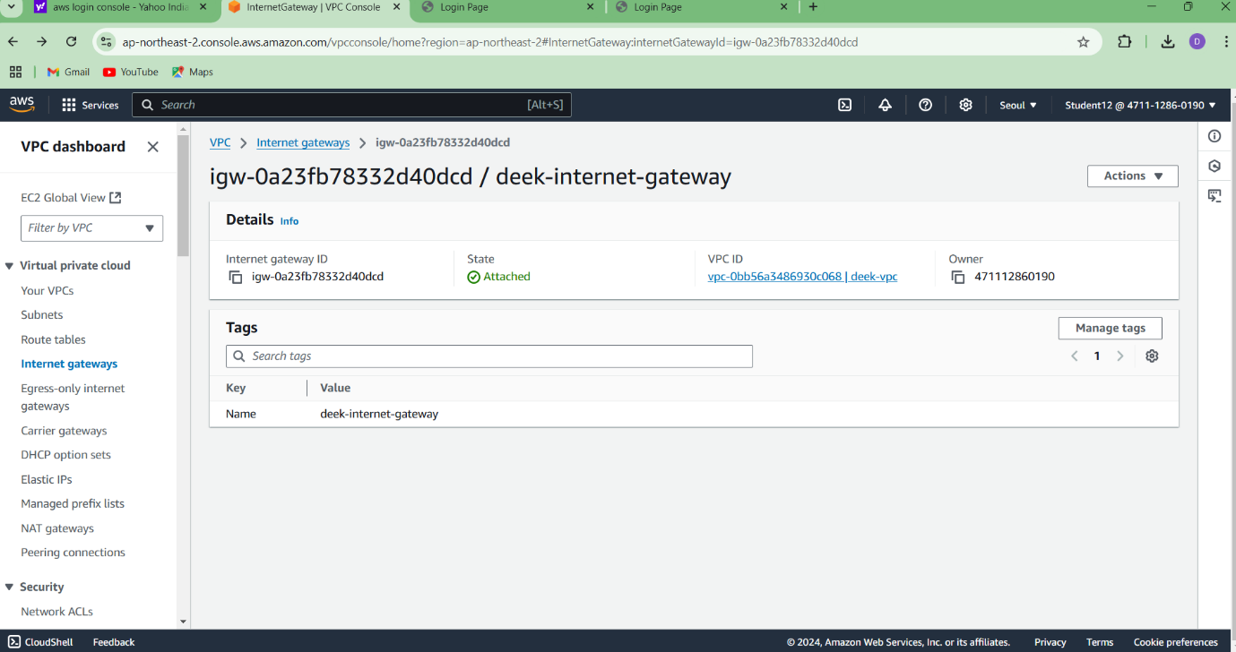

**Public Subnet**

Steps:

1. In VPC dashboard, select Subnets.

2. Click create subnet button.

3. Select the appropriate VPC ID.

4. Provide Subnet name as public-subnet1 and select the appropriate avalaiblity zone and provide the IPv4 subnet CIDR block as 10.0.1.0/24.

5.Create another subnet by clicking add new subnet by providing public-subnet2and select the appropriate avalaiblity zone and provide the IPv4 subnet CIDR block as 10.0.2.0/24.

6.Click create subnet button.

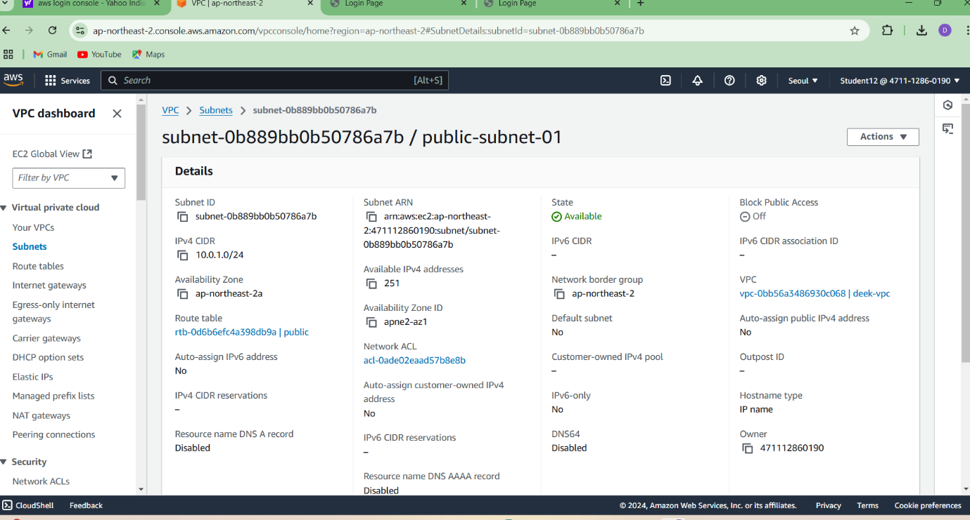

**Router table**

Steps:

1. To create Route table, click on create route table.

2. In route table setting, give route table name as deek-route-table-01 and select vpc that is created.

3. Then click on create route table.

4. After route table is created, go to routes and click on edit route and then click on add route.

5. Then in destination, select 0.0.0.0/0 as destination and target as Internet Gateways.

6. After selecting internet gateway, it allows to select the igw- and select the internet gateway that is created by you.

7. At last click on save changes.

8. Then go to subnet association and click on edit subnet association.

9. Select the subnet you have created and click on save changes.

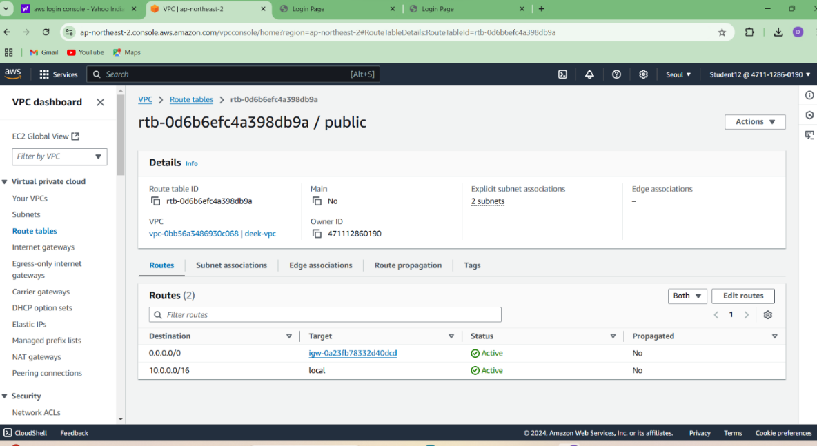

**EC2 instance**

Steps:

1. Go to EC2 in AWS console and click on instances.

2. Click on launch instance and give the name for the instances as deek- server.

3. After giving name to instances, select application and OS Images as Amazon Linux and instances type as t2.micro.

4. In keypair, click on create keypair and give keypair name as deek-keypair and click on create keypair. The keypair is created.

5. Then in network setting, click edit. Select vpc and subnet and also assign public IP as enable.

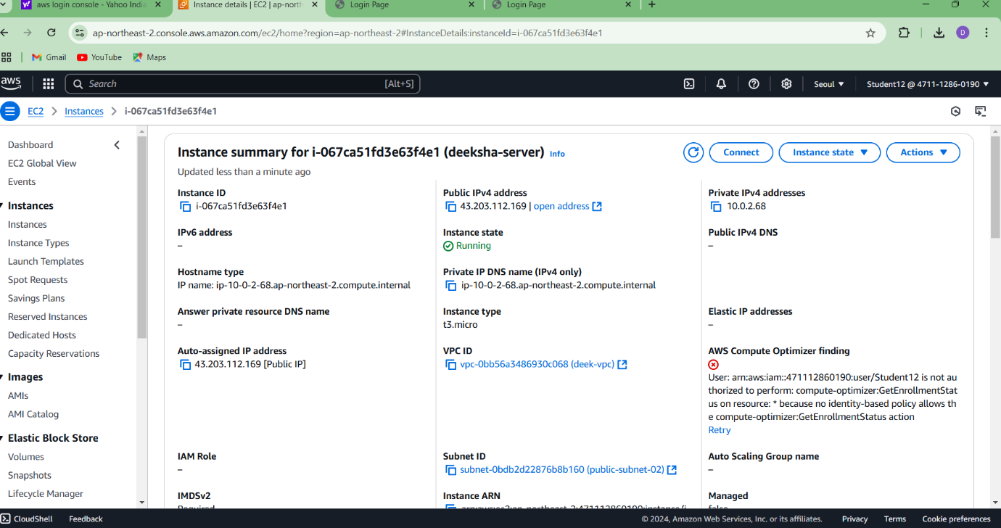

**Connection**

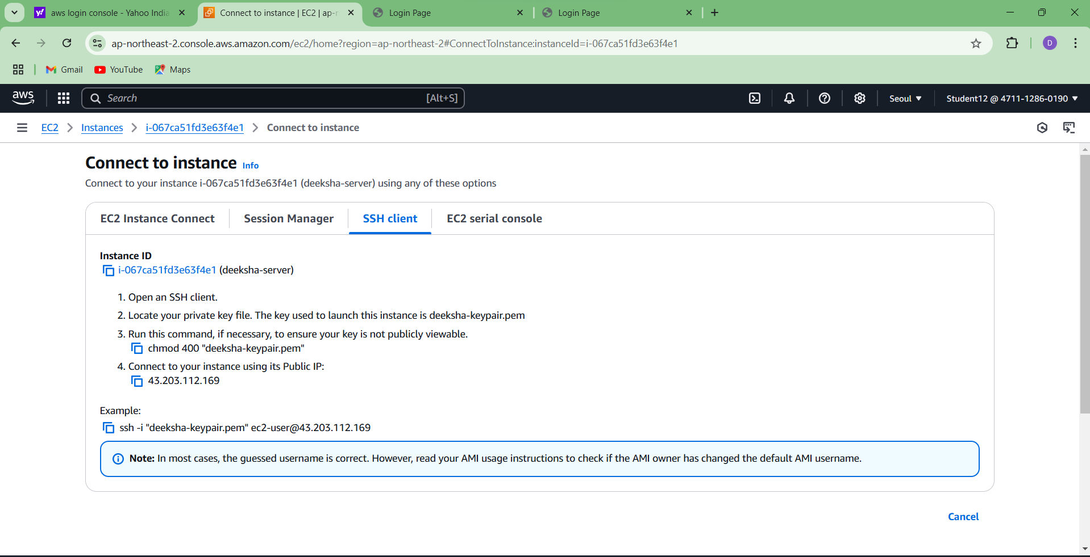

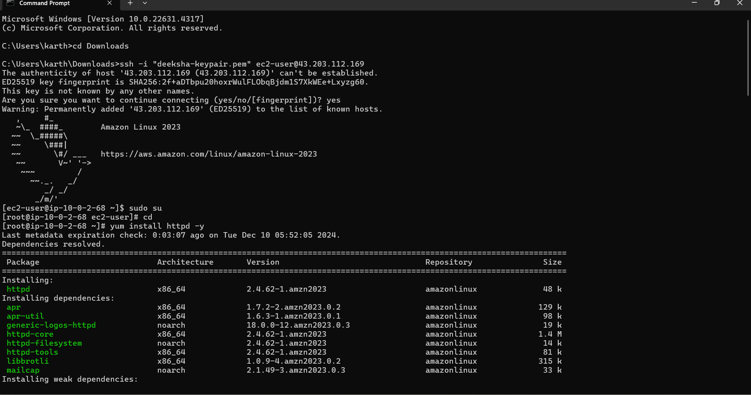

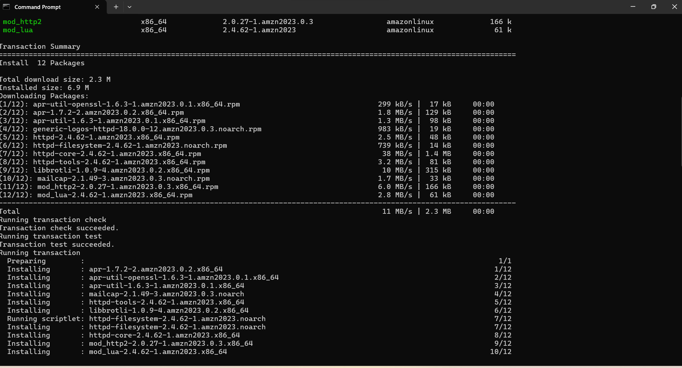

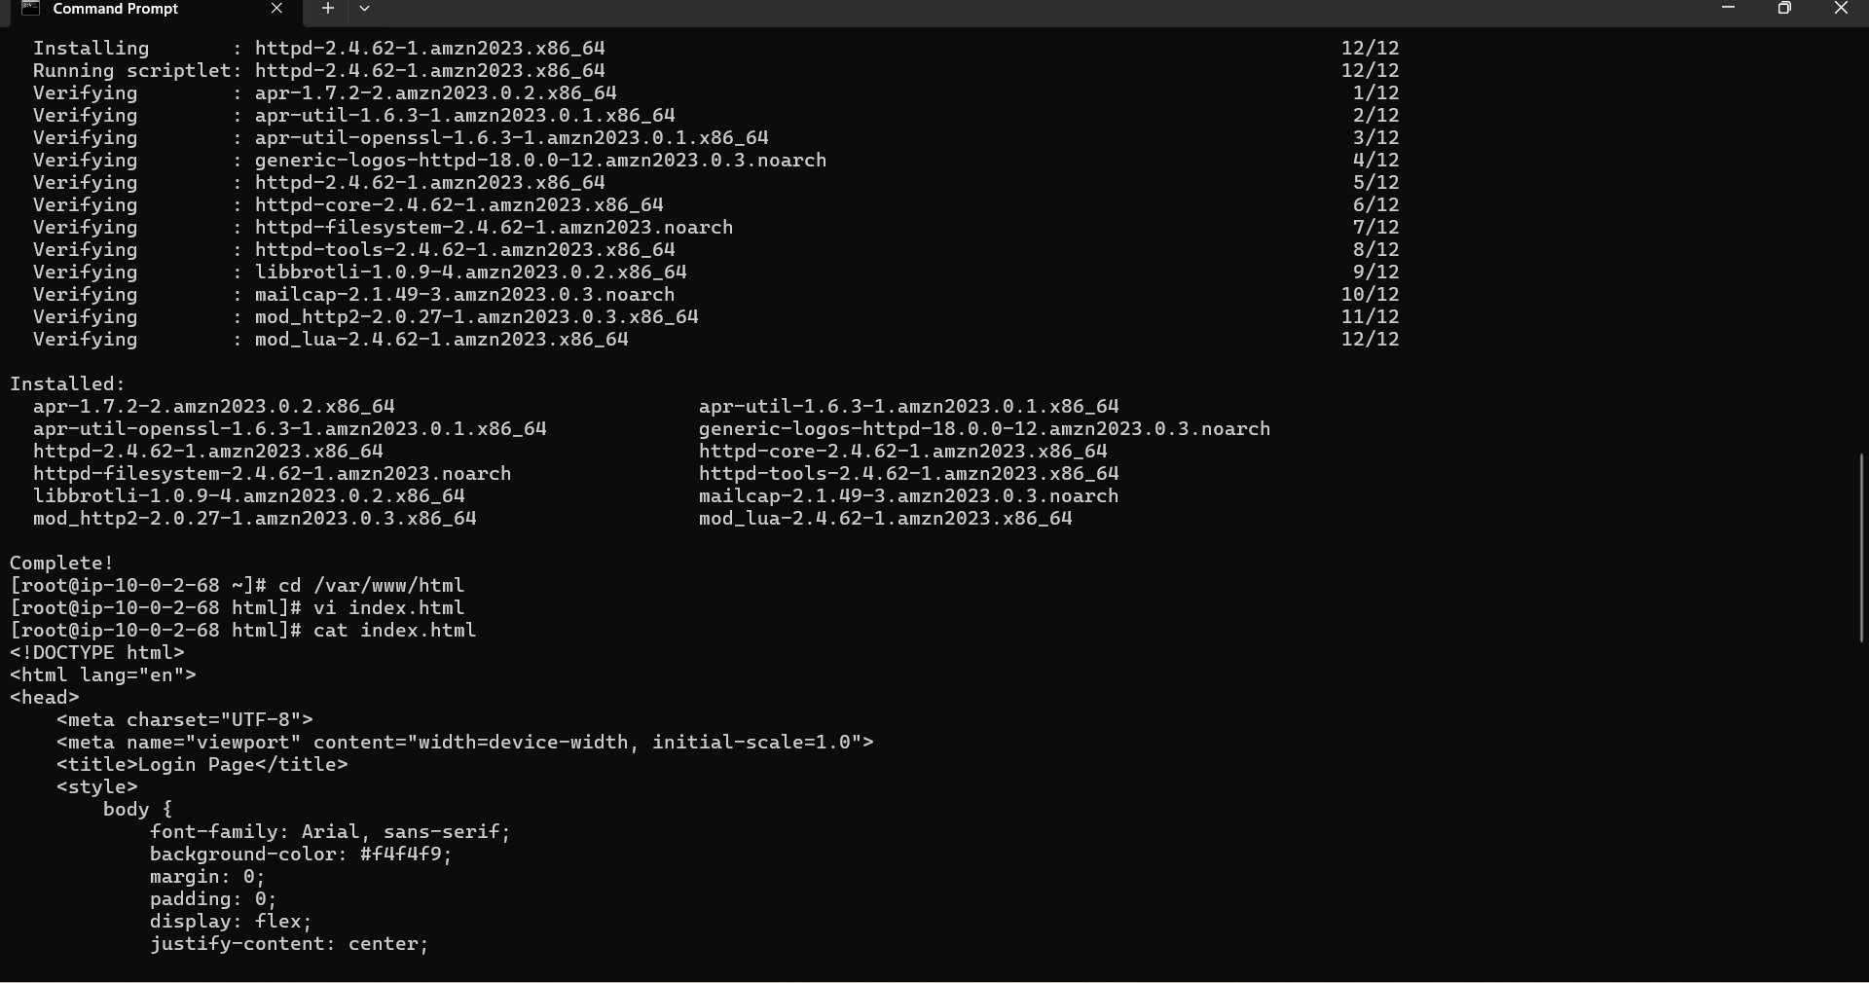

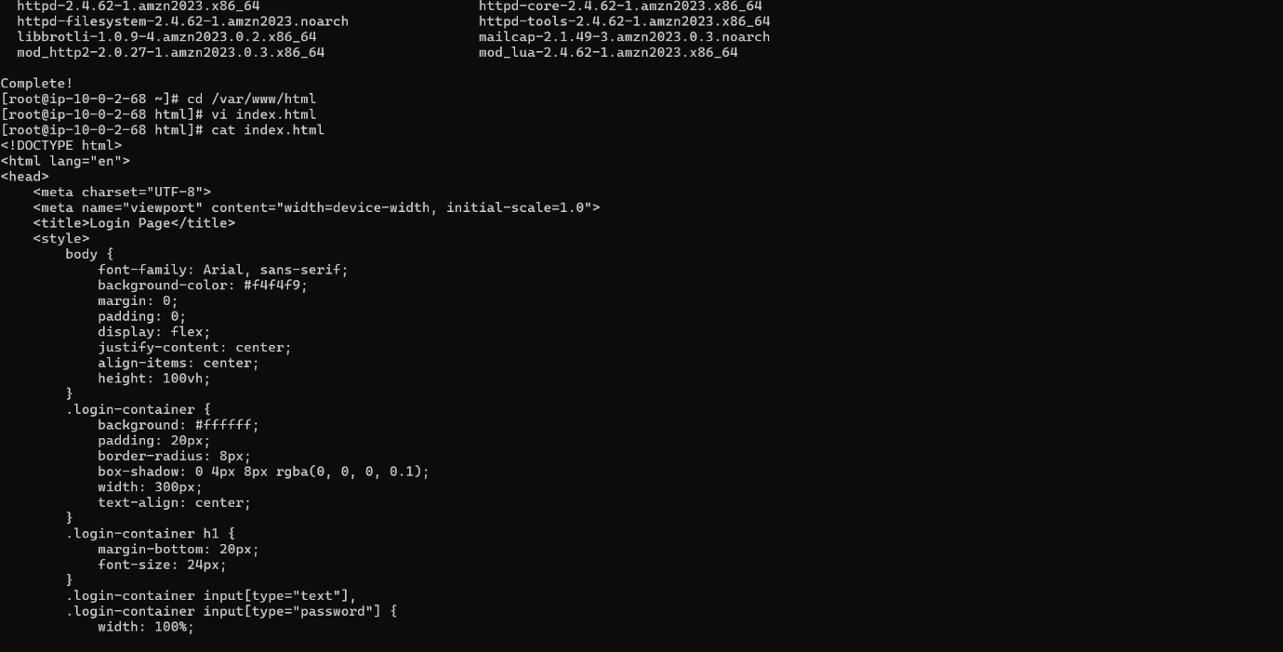

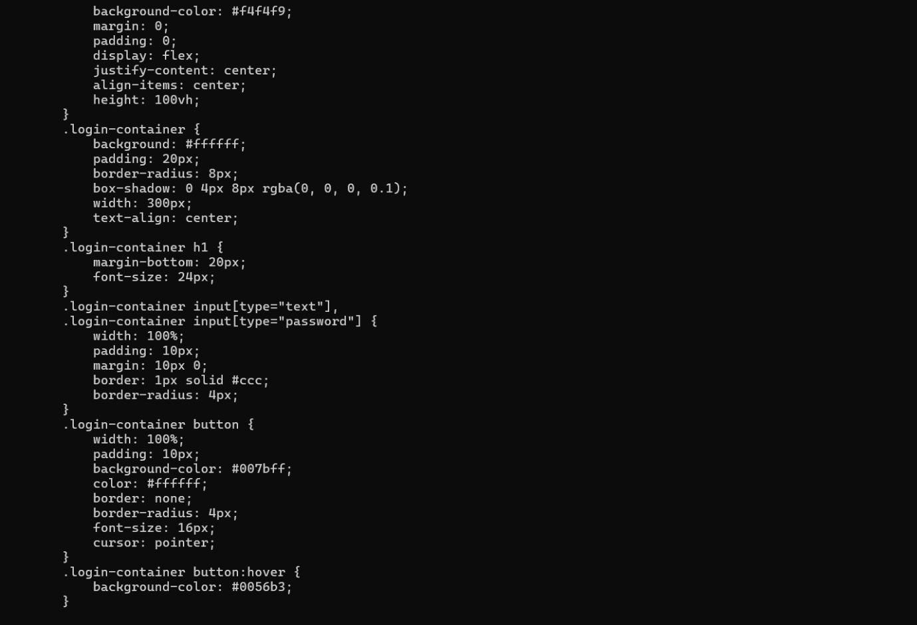

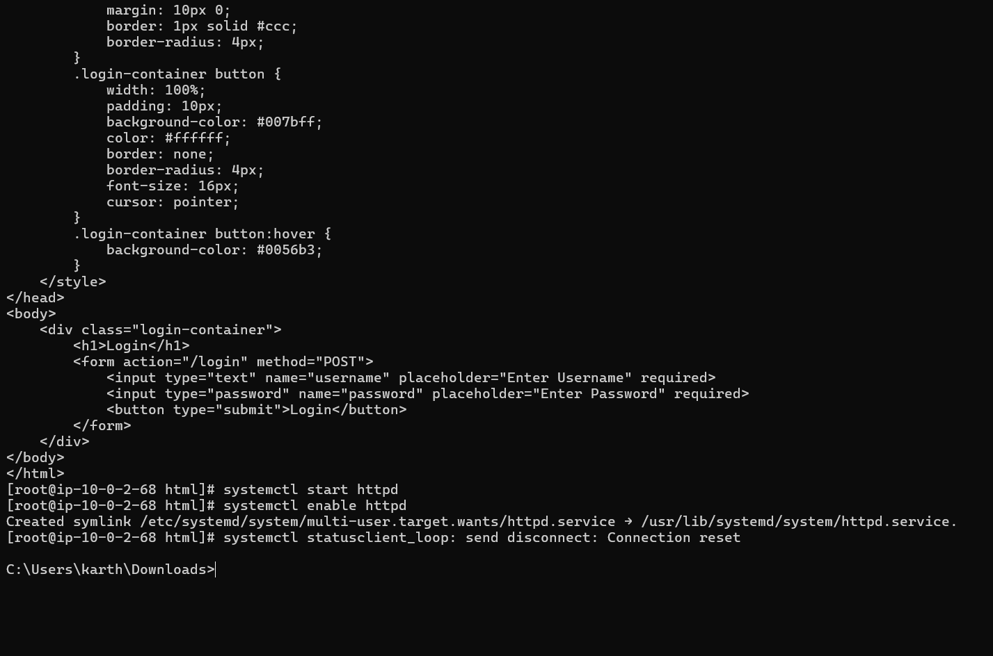

**Final result**

